**Myntra Data Analysis and insights using Power BI:**

“If you torture data long enough, it will confess to anything”- Guys this is a very famous quote said by Ronald Coase, Noble prize winning economist that means the more questions you ask your dataset, it will give you more detailed insights.

And today we will be discussing a powerful tool that helps you to do the same – that is PowerBI

Hello everyone, welcome to fingertips, today in this tutorial we will explore the basics of Power-BI, including its components, importance, architecture and the main part Dashboard.

AGENDA… (SLIDE Presentation)

1. Introduction to BI
2. Data visualization & Tools used for data visualization
3. What is Power BI
4. Components of PBI
5. Architecture of PBI
6. Dashboard Practical (**Download and install PBI desktop, Charts& maps, Tables, matrix, formatting, Cards & filters, Slicers, insert Image, buttons, text box, DAX, Power Query, Bookmark & selection pane, dashboard**)

To make this tutorial interesting, we will be using a rich source of data on a fashion e-commerce platform and of course the favorite of yours-**Myntra that has a** fascinating collection of data on thousands of products, brands, categories, ratings, reviews, discounts, and lot more.

But first, let’s dive into the overview of Power-BI with the help of an example.

Imagine you're running a store and you want to know which products are selling the most, which customers are buying the most or which days of the week are the busiest. So, here you will start collecting and analyzing data from your sales records, you can get a better understanding of what's happening in your store and make informed decisions about what products to stock, when to schedule staff, and how to price your products.

It can be a tiring job…right? And guys here BI can come to your rescue.

Business intelligence tools make it easier to collect, analyze, and present this kind of data, so that businesses can make more informed decisions based on concrete facts rather than gut feelings or guesswork. So, Business intelligence (BI) is the practice of gathering, analyzing, and presenting information through BI tools in a way that helps businesses make better decisions.

There are many Bi tools present in market like Tableau, Qlikview but the one that is highly used is Power-BI. Guys Power BI is a business analytics service by Microsoft that allows you to analyze data and share insights. It enables you to connect to various data sources, transform and clean the data, create interactive visualizations, and share reports and dashboards with others.

So let’s now discuss about different components of Power BI.

Slide[4. Components of PBI]

Starting with power query: Power Query is one of the important components of Power BI. Guys using Power Query, you can delete and extract data from a wide range of databases like Oracle, SQL Server, MySQL, and many more. It uses a simple language that is known as M-formula language.

Next comes, power pivot which is data modeling and calculation engine. And it uses DAX that is Data Analysis Expressions as a language, which is a strongly functional language, and all your calculations are done here.

Then we have power view which is the fundamental data visualization component of power bi.

Then we have power map which is used to visualize geospatial data in 3D mode.

Then comes power QnA, it’s a ordinary language motor. So, after assembling data model and updating it on Power BI Website, you can ask questions, and get solutions to those questions.

Next is power BI desktop it’s an integrated development tool for Power Query, Power Pivot, and Power View.

Then we have power BI website, guys you can create dashboards for your reports and share them with others, and also you can create reports directly on the Power BI Website.

Power BI mobile apps, it have three mobile operating systems (OS) providers: Android, iOS, and Windows. So you can share your reports & dashboards from your mobile app.

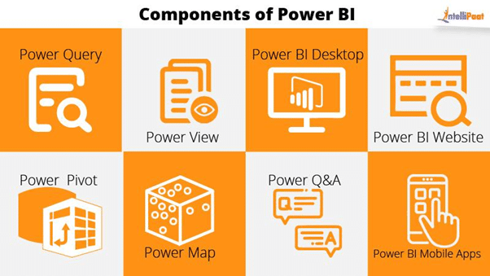

So now as we have seen different components, let’s now understand architecture of power bi.

Slide [5. Architecture of PBI]

Power bi architecture consists of 3 main parts, Data preparation, visualization, and business user. Data preparation involves cleaning, transforming, and modeling the data for analysis using tools like Power Query and the Data Model. Visualization involves creating interactive reports and visualizations using options like charts, tables, and maps. Finally, the business user is the end user who interacts with the data and visualizations to gain insights and make informed decisions. The Power BI architecture connects these components by providing tools and components enabling business users to gain valuable insights from their data.

Top of Form

Bottom of Form

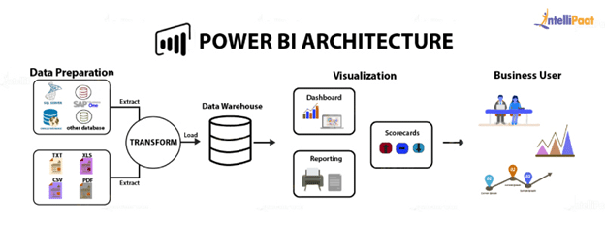

So before starting analyzing data and making insights let’s first have a look at the dashboard we are going to create. It consists of different charts, maps, matrix, filter slicers,cards interactive buttons and much more. So its gonna be a very interesting tutorial guys.

Slide [6. Dashboard]

And here is the **dashboard**we are going to create today which includes answers of all the questions we asked.

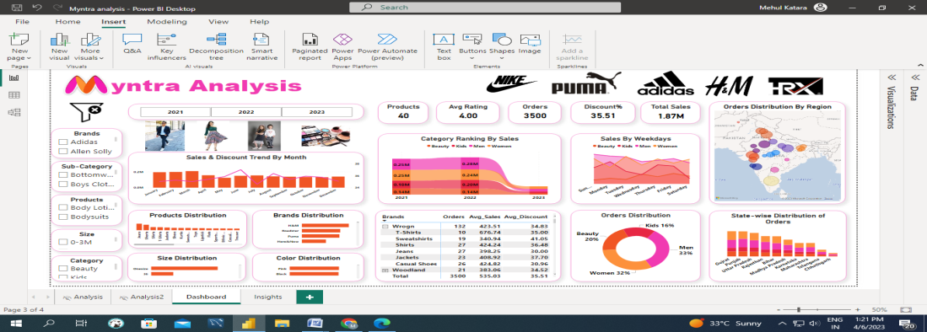

Now since we are going to analyze myntra data, why not go to its website and have a glimpse of what category of products are being offered at what price and how much discount is offered by which brand.

[WEBSITE… guys seeing this we can answer questions like…, but can’t answer…by just looking at this website. So we are going to answer these questions using Power BI and will make useful insights out of it.]

**Practical Script:**

**So let’s start…**

1. we are going to start with very beginning from downloading& installing power BI
2. Import dataset
3. Understand-PBI interface
4. Data cleaning- power query editor (Transform data) - Remove null values, Remove duplicates, Remove columns, rename columns,split columns, merge columns, extract data, replace data, trim & clean data, changing data type, sorting data, filtering data
5. M-language
6. Calculated columns, custom columns in power BI
7. Calculated tables in power BI
8. How to create Measures in Power BI-DAX(Data Analysis Expressions)
9. Data Modeling
10. And after all this, the journey to analysis will begin…basic charts & graphs, matrix & tables and we’ll use all this to answer some important questions
11. We will then combine all visuals-dashboard in power BI-**Overview, category, brand, insights**
12. We’ll learn how to do dashboard formatting, insert image, add slicers, edit interactions, use filters, buttons-page navigator
13. And at last we will make insights out of whatever the analysis we have done.
14. **Download and install power BI Desktop**
15. **Data Import**
16. **Power BI Desktop interface**
17. **Data Cleaning-Power Query Editor (Transform data)-**Remove null values, Remove duplicates, Remove columns, rename columns, changing data type, sorting data, filtering data
18. **M-language**
19. **Calculated columns**
20. **Calculated table**
21. **Measures**
22. **DAX**
23. **Data Modeling**
24. **Basic Graphs**
25. **Table & matrix**
26. **Trend lines**
27. **QnA**
28. **Dashboard/Report-Overview, category, brand, insights**
29. **How to insert an image in PBI**
30. **How to add Slicers**
31. **Edit interactions**
32. **Filters**
33. **Dashboard formatting**
34. **Buttons-page navigator**
35. **Insights**
36. Download and install Power BI Desktop: Power BI Desktop is a tool that helps you create reports and dashboards by analyzing and visualizing data. To use it, you need to download and install it on your computer.
37. Data Import: Before you can start creating reports and dashboards in Power BI Desktop, you need to import your data into the tool. You can import data from various sources like Excel files, databases, or cloud-based platforms like Microsoft Azure.
38. Power BI Desktop interface: Power BI Desktop has an easy-to-use interface that allows you to create reports and dashboards. The interface consists of various tabs like Home, Modeling, View, and others, which help you perform different functions.
39. Power Query Editor: Power Query Editor is a data transformation tool within Power BI Desktop that helps you clean and transform your data. You can use it to remove duplicates, filter data, and add new columns to your data.
40. Data Cleaning: Data cleaning is the process of identifying and fixing errors, inconsistencies, and inaccuracies in your data. In Power BI Desktop, you can use various tools like Power Query Editor to clean your data.
41. M-Language: M-Language is a programming language used by Power Query Editor to transform and clean data. You don't need to know the language to use Power Query Editor, but knowing it can help you perform more complex transformations.
42. Calculated columns: Calculated columns are columns that you add to a table in Power BI Desktop. You can use them to perform calculations on existing columns or create new ones based on existing data.
43. Calculated table: A calculated table is a table that you create in Power BI Desktop by performing calculations on existing data. You can use it to create a new table with data that isn't in your original dataset.
44. Measures: Measures are calculations that you create in Power BI Desktop that are based on the data in your dataset. You can use measures to perform calculations like sums, averages, and percentages.
45. DAX: DAX is a formula language used by Power BI Desktop to create measures and calculated columns. It's similar to Excel formulas but has more advanced features.
46. Data Modeling: Data modeling is the process of organizing and structuring your data in Power BI Desktop. It involves creating relationships between tables and defining measures and calculated columns.
47. Basic Graphs: Power BI Desktop allows you to create various types of visualizations like bar charts, line charts, and pie charts. You can use these visualizations to analyze your data and gain insights.
48. Table & matrix: Table and matrix are two types of visualizations that you can create in Power BI Desktop. Tables display data in a tabular format, while matrices display data in a pivot-table format.
49. Trend lines: Trend lines are a type of visual aid that you can add to a chart in Power BI Desktop. They show the trend or pattern in the data over time.
50. QnA: QnA is a feature in Power BI Desktop that allows you to ask questions about your data using natural language. It uses AI to understand your questions and provides answers in the form of visualizations.
51. Dashboard/Report: A dashboard is a collection of visualizations and reports that provide an overview of your data. A report is a detailed analysis of your data that includes visualizations and insights.
52. How to insert an image in PBI: To insert an image in Power BI Desktop, you can click on the "Image" option in the "Visualizations" pane and select the image file you want to use.
53. How to add Slicers: Slicers are a type of visual aid that allows you to filter data in a report or dashboard. To add a slicer in Power BI Desktop, you can select the "Slicer" option from the "Visualizations" pane and then choose the field that you want to use as a filter.
54. Edit interactions: Edit interactions is a feature in Power BI Desktop that allows you to control how visualizations interact with each other in a report or dashboard. You can use it to filter data based on the selection made in another visualization.
55. Filters: Filters are a way to limit the data displayed in a visualization based on specific criteria. You can add filters to a report or dashboard to focus on a specific subset of data.
56. Dashboard formatting: Dashboard formatting refers to the process of customizing the appearance of a dashboard to make it more visually appealing and easy to understand. You can change the color scheme, font, and layout of your dashboard in Power BI Desktop.
57. Buttons-page navigator: Buttons-page navigator is a feature in Power BI Desktop that allows you to create buttons that navigate between different pages or sections of a report or dashboard. You can use it to create a more interactive and intuitive experience for users.

**Questions to answer:**

1. **How is Sales percent of different categories changing over years?**

**25% decrease in Sales for women category from Qtr1 to 2, 10% decrease from 2 to 3**

1. **How is ranking percent by sales of different categories changing over years?**

**Men were on rank-1 for years 2021 & 2022 while rank dropped down to 2 in year 2023(data till March). From Jan-Feb men’s rank dropped down from 1 to 3 and women’s rank raised from 2 to 1.**

1. **Which city of Gujrat is placing highest orders?**

**Ahmedabad**

1. **Which color is most popular among males?**

**Black**

1. **Which brand jeans are most purchased by men?**

**H&M**

1. **Which product is most sold by NIKE?**

**Sports Shoes**

1. **Which brand is most popular for beauty products?**

**Loreal**

1. **What is Brand-wise distribution for lipsticks?**

**Highest by Lakme, lowest by MyGlamm**

1. **Which color jackets are least purchased?**

**Red**

1. **Which size products are most commonly sold in kids category?**

**3-4 Years**

1. **Which brand on Myntra is generating highest sales revenue?**

**Puma**

1. **Which brand is offering least discount for women’s jeans?**

**Cantabil**

1. **H&M products are most sold in which city?**

**Bengaluru**

1. **Distribution of products among all states/cities?**

**Map**

1. **Sales & Discount Trend over time(month, year) for each category🡪explain**
2. **Highest sales are made on which day of the week for each category?**

Insights:

**Practical Topics:**<https://www.kaggle.com/datasets/manishmathias/myntra-fashion-dataset>